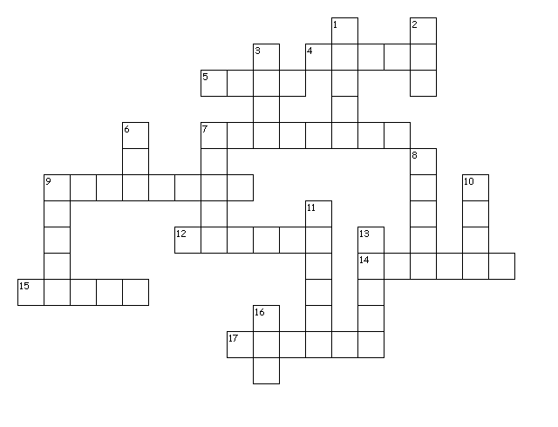
Norse Gods Cross Word Puzzle

Across
4. God of poetry and eloquence. Husband of Idunn.
5. God of thunder. His weapon is the magic hammer Mjollnir
7. The God who guards the bifrost bridge, which is the entrance to Asgard
9. The giantess who mated with Loki to create Hel, Fenrir, and The Midgard Serpent.
12. Wife of Odin. Spinner.
14. Wife of Bragi. Keeper of the golden apples of eternal youth
15. God of prosperity and fertility. Symbol is a Boar. Brother of Freya
17. A monstrous wolf conceived by Loki. Wolf that bites Tyr's hand off.
Down
1. Goddess of fertility and seithr. Sister of Freyr
2. Wife of Thor. Has magic golden hair
3. A trickster. Sly, deceitful, master thief, not to be trusted.
6. God of law and justice. The only God with the strength and courage to bind Fenris.
7. Blind. Tricked by Loki into killing Balder
8. The chief of the Vanir. A sea God.
9. Alebrewer. So called because he loves to give feasts for the Gods.
10. Chief of the Aesir. Gave up his eye for wisdom.
11. The God who dies and rises again. Loki tricked Hoder into killing him.
13.The guardian of a spring of wisdom at the roots of Yggdrasill.
16. Goddess of death. Daughter of Loki.

Word Bank

Aegir Angrboda Balder Bragi
Fenrir Freya Freyr
Frigga Hel Hoder Heimdall
Indunn Loki Mimir Njord
Odin Thor Sif Tyr

